**Exploring Integrity and Avoiding Plagiarism**

This lesson will guide you through thinking about integrity as an important personal quality and an academic necessity. This quality is an admirable one, and it impacts many parts of our lives, including the choices we make and our relationships with others (to name a few).

**Academic Integrity**

Often, we consider integrity to mean ‘doing the right thing’ even when it is inconvenient for us. Integrity focuses on our inner sense of right and wrong. Integrity directs us to be truthful in our relationships with others. Integrity encourages us to be honest with our families, peers and those around us.

***Integrity inspires trust.***

Academic integrity is very important, especially for students. When we have integrity, we take ownership of what we do and what we know. Academic integrity means we acknowledge information that is not ours by providing information for the reader about our sources. Academic integrity requires practice so that it becomes a habit. By practicing academic integrity, we are more likely to have integrity in other parts of our lives.

Having academic integrity allows all of us to build knowledge. Those who read your work will have an opportunity to read what you have read, and build on what you have read. This is how new ideas are born and innovations in our society are made!

**Challenges to Integrity**

Our integrity is challenged when our lives test us: busy schedules, pressure from within ourselves, by our peers, our parents and our teachers, or when we are just overwhelmed with the amount of work we have to do. When we feel challenged in these ways, we need to remember that resources are available to help us.

**The Integrity Challenge**

Meet Joe.

He’s in a tough situation.

**The Skinny of the Issue**

While going to school full-time, Joe works in the evenings and plays hockey. Good grades seem to come easily to his friends, but he struggles with his assignments. Being a slow reader, he feels it takes him a long time to understand what he’s reading, let alone tackle the assignments. He wants to keep up with his friends in school. With a big paper due on Monday and a hockey game out of town this weekend, Joe is tempted to go to the Internet to find a paper he can submit instead of writing his own.

**What challenges Joe’s integrity in this situation?**

Joe’s challenge appears in his temptation to take an assignment from the Internet and submit it as his own work. He hopes that in doing so he can save time, and he will earn higher marks. He wants to join his team in the hockey game this weekend as well. He thinks that taking the paper from the Internet will give him the time he needs to go to the game.

**What are Joe’s options?**

1. Joe can either complete the paper before he goes to the game or not attend the game at all.
2. Joe could ask his teacher if he can have an extension so that he can do the assignment properly.
3. Joe can submit a plagiarized assignment.

**What are the potential consequences for Joe?**

1. If Joe explains to his coach that he can’t make the game unless the assignment is finished, his coach will likely encourage him to do so.
2. If he requests an extension from his teacher, the teacher may be more willing to help him complete the assignment. His teacher will also respect that he considers his work important and trust him in the future.
3. If he hands in plagiarized work and his teacher reports it, he would be punished according to his school’s plagiarism policy. This may result in a zero for the assignment, academic probation, or being removed from the class. Being removed from the class would require him to stay in school for an extra semester. Some of these punishments would be quite public, and his friends may disrespect him for cheating.

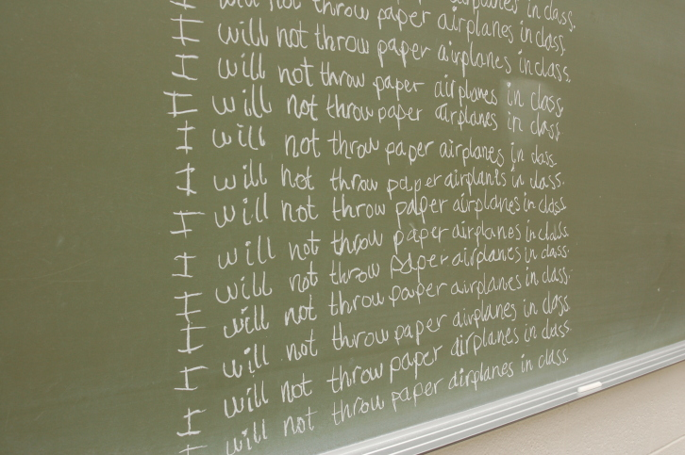

**Acknowledging Sources**

Regardless of whether you quote directly or paraphrase what you read when working on research assignments, you need to credit the original source of that knowledge. To use a technical term, you need to “cite” your sources. **You cannot present information you find elsewhere as your own knowledge**.

Information that does not need to be referenced, are real life examples you provide in your work, or when you apply what you read and reveal your own understanding. This information is yours!

Some information on how to credit your sources appropriately is on pp. 177- 182 in your *Communicate* textbook. There are also some very good websites that can help you as well. For example, if you search for The John F. Kennedy Library Foundation, you will find some helpful links on how to avoid plagiarism.

Hassan has also prepared a presentation on searching the internet and on bibliography tips that you have already previewed earlier in the course. You can review the tutorial “**The Goods: Finding and Using Good Information”** on the **Course Resource USB** or in the **Course Resource book**.

